For Immediate Release

WTTC PROCLAIMS THE PHILIPPINES AMONG WORLD’S TOP 15 TRAVEL, TOURISM POWERHOUSES

The World Travel & Tourism Council (WTTC)’s Power and Performance Report 2018 pronounced the Philippines as among the top 15 tourism powerhouses, reporting “absolute growth” within the period of 2011 to 2017. The country ranked 13th among 185 countries assessed on its respective travel and tourism sector’s performance in four main indicators: capital investment, contribution to the gross domestic product (GDP), international visitors spend and domestic spend.

Remarking that the Philippines is the only country in the top ten to rank for GDP contribution in size and strength, as well as power and performance, this Southeast Asian nation made an additional US$36.5 billion in 2017, growing at an impressive annual rate of 14.2% over the said seven-year period.

Tourism Secretary Bernadette Romulo-Puyat confirms that Philippine tourism is, indeed, on the rise. Sec. Romulo-Puyat shares over the ministerial round table of Tourism Expo 2018 in Japan that the Philippines is “more than five years ahead” of its domestic tourism targets.
In 2017, the tourism industry contributed 12.2% to the Philippines’ GDP, exceeding the government 2022 target of 10% share. The Department of Tourism (DOT) Philippines recorded at least 96.7 million domestic tourist arrivals for the same year, well beyond the 2022 target of 86.2 million. 6.62 million International arrivals were noted for 2017, which is a record-high for the Philippines.
The Philippines Department of Tourism will be at the World Travel Market in London this week. Mr. Arturo Boncato, Jr., Undersecretary, Tourism Regulation Coordination and Resource Generation (TRCRG), Philippine Department of Tourism (PDOT) along with Ms. Marie Venus Q. Tan, Chief Operating Officer, Tourism Promotions Board (TPB) – Philippines would love the opportunity to welcome you at their stand AS1000. They will have a stand opening event at 10am on Monday, 5th November and a press and MICE briefing at 3pm on Tuesday, 6th November. They will have serving some traditional food & drinks and giving away several prizes.
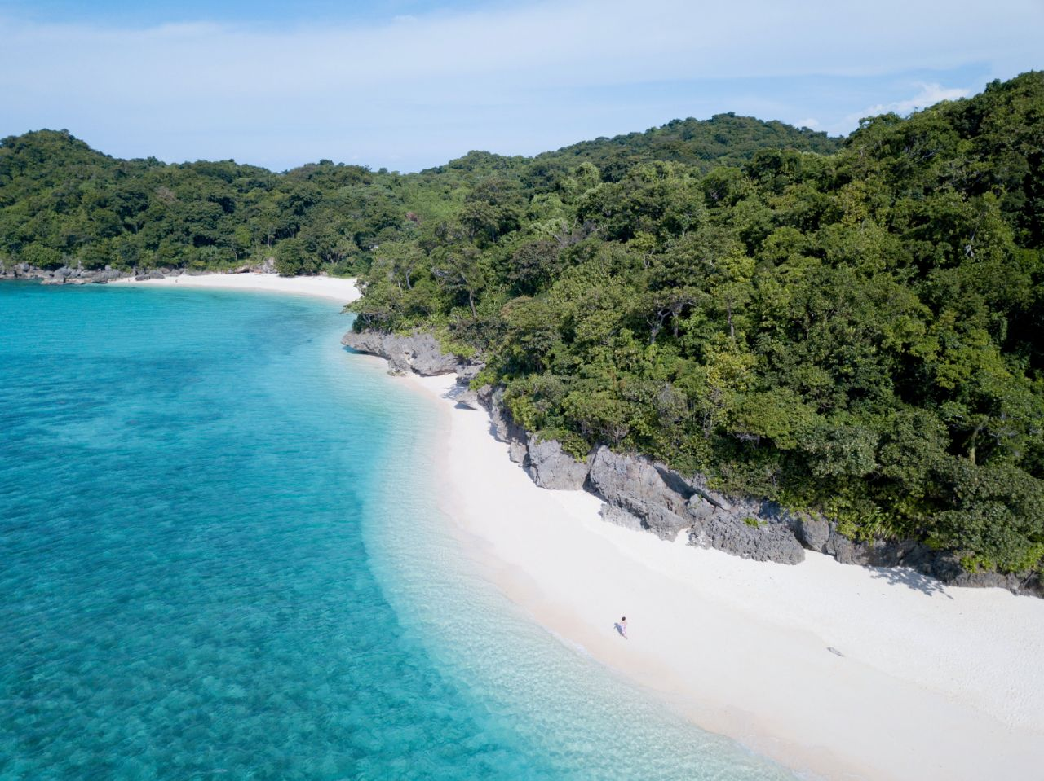
Boracay

For more information, please go to www.itsmorfuninthephilippines.co.uk

